

UNIVERSITY OF HERTFORDSHIRE
School of Physics, Engineering and Computer Science

Comparative Evaluation of Workforce Forecasting Models for E-Commerce Fulfilment Centre Operations Using a Spring Boot Analytics Platform

MSc Cyber Security
7COM1039-0509-2025
Advanced Computer Science Masters Project
02nd June 2026
MSc Cyber Security
7COM1039-0509-2025
Advanced Computer Science Masters Project
02nd June 2026

Contents
1.Introduction 2
2.Literature Review 2
2.1Workforce Planning and Capacity Management 3
2.2 Forecasting Techniques 3
2.3Operational Analytics and Decision Support Systems 3
2.4 Research Gap 3
3 Aim and Objective 3
3.1 Aim 3
3.2 Objectives 3
4. Research Questions 4
5. Methodology 4
6. Expected Outcomes 4
6.1 Expected System Components 5
7. Timeline 5
8. References 6

1.Introduction
Workforce planning is a critical function within e-commerce fulfilment centres where labour demand frequently changes due to seasonal sales, promotional campaigns, special events, and fluctuations in customer orders. Accurate workforce planning ensures that sufficient staff are available to meet operational requirements while maintaining productivity and controlling labour costs (Chopra and Meindl, 2019).
Many organisations continue to rely on traditional planning approaches such as manual estimation, historical observations, and spreadsheet-based planning. These methods often struggle to adapt to rapidly changing workloads and may result in understaffing, overstaffing, increased overtime costs, reduced productivity, and operational inefficiencies (Waller and Fawcett, 2013).
Recent advancements in data analytics and forecasting techniques have enabled organisations to make more informed workforce planning decisions. Various forecasting models have been proposed in the literature to predict future workforce requirements. However, selecting the most suitable forecasting approach remains a challenge due to differences in prediction accuracy, implementation complexity, and operational usefulness (Hyndman and Athanasopoulos, 2021).
This research aims to evaluate existing workforce forecasting approaches within an e-commerce fulfilment centre environment and identify the most effective technique for supporting workforce planning decisions. A Spring Boot-based analytics platform will be developed to facilitate forecasting experiments, result visualisation, and performance analysis.

2.Literature Review

The literature review will focus on three major research areas.

2.1Workforce Planning and Capacity Management

Previous research highlights workforce planning and capacity management as key factors in improving operational efficiency and reducing labour costs.

2.2 Forecasting Techniques
Research has explored both statistical and machine learning techniques for workforce demand forecasting. Studies have shown that forecasting accuracy varies depending on the dataset and operational environment.

2.3Operational Analytics and Decision Support Systems

Analytics dashboards and performance metrics are widely used to support workforce planning and operational decision-making.

2.4 Research Gap

Although existing research has investigated forecasting techniques and workforce planning practices, limited studies have evaluated forecasting models specifically within fulfilment centre operations while integrating forecasting results into an operational analytics platform. Furthermore, many studies focus primarily on prediction accuracy without considering the practical implications of workforce planning and operational decision-making.
This research aims to address this gap through a comparative evaluation of forecasting approaches within a fulfilment centre context while assessing their usefulness for workforce planning decisions.

3 Aim and Objective

3.1 Aim

To implement, compare, and evaluate workforce forecasting approaches within an e-commerce fulfilment centre environment and determine the most effective method for supporting workforce planning and operational decision-making.

3.2 Objectives

- To investigate workforce planning and capacity management practices used in e-commerce fulfilment centres.
- To review forecasting approaches commonly used for workforce demand prediction.
- To identify operational metrics that influence workforce planning effectiveness.
- To implement selected forecasting approaches identified through the literature review.
- To develop a Spring Boot analytics platform for experimentation, visualisation, and reporting.
- To evaluate forecasting approaches using appropriate performance metrics.
- To compare the effectiveness of forecasting techniques for workforce planning and operational decision-making.
- To provide recommendations for workforce planning within fulfilment centre operations.

4. Research Questions

- How do different workforce forecasting approaches perform within e-commerce fulfilment centre operations?
- Which forecasting approach provides the highest prediction accuracy for workforce demand forecasting?
- What operational metrics have the greatest influence on workforce planning effectiveness?
- How effective are forecasting approaches in supporting workforce planning and operational decision-making?
- Which forecasting technique provides the most suitable balance between prediction accuracy, implementation complexity, and operational usefulness?

5. Methodology

This project will adopt a comparative research methodology to evaluate workforce forecasting models for e-commerce fulfilment centre operations. Historical workforce and operational datasets will be collected from publicly available sources and prepared through data cleaning and transformation processes.
Exploratory Data Analysis (EDA) will be conducted to identify patterns, trends, and seasonal variations within the data. Based on the literature review, selected statistical and machine learning forecasting models will be implemented and tested.
A Spring Boot-based analytics platform will be developed to support data management, forecasting execution, result visualisation, and performance comparison. The models will be evaluated using metrics such as Mean Absolute Error (MAE), Root Mean Square Error (RMSE), and execution time.
The results will be compared to determine the most effective forecasting approach for workforce planning, and recommendations will be provided based on the findings.

6. Expected Outcomes
The project is expected to produce a comparative evaluation of workforce forecasting approaches within an e-commerce fulfilment centre environment.
A Spring Boot analytics platform will be developed to support forecasting experiments, performance comparison, and result visualisation.
The study will identify the strengths and limitations of different forecasting approaches and determine which technique provides the most effective support for workforce planning decisions.
The research will also provide practical recommendations for organisations seeking to improve workforce planning through data-driven forecasting and analytics.

6.1 Expected System Components
Proposed System Workflow
The Spring Boot analytics platform will allow users to upload workforce datasets containing staffing and operational information. The system will process and prepare the data for analysis. Selected forecasting models will then be executed to predict future workforce demand. The generated forecasts will be evaluated using performance metrics such as MAE and RMSE. Results from different forecasting models will be compared through dashboards and visualisations, enabling users to identify the most effective forecasting approach. Finally, reports can be generated to support workforce planning and decision-making.
The Spring Boot analytics platform will include:
- Dataset Upload and Management
- Forecasting Execution Module
- Analytics Dashboard
- Forecast Comparison Dashboard
- Report Generation Module
- PDF and Excel Export Functionality
- Performance Evaluation and Visualisation Tools
The platform will serve as a research tool for conducting forecasting experiments and analysing results rather than as a full workforce management system.

7. Timeline
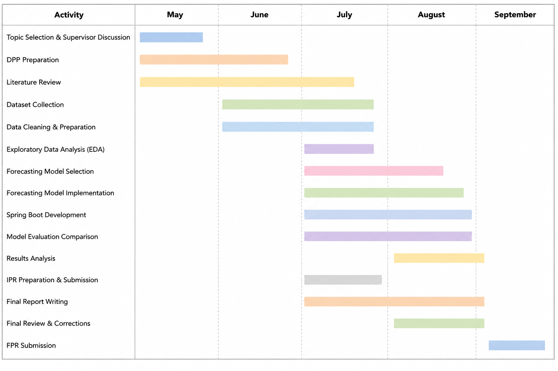

8. References
- Hyndman, R.J. and Athanasopoulos, G. (2021) Forecasting: Principles and Practice. Available at: https://otexts.com/fpp3/
- Chopra, S. and Meindl, P. (2019) Supply Chain Management: Strategy, Planning and Operation. Pearson. Available at: https://www.pearson.com
- Waller, M.A. and Fawcett, S.E. (2013) ‘Data Science, Predictive Analytics, and Big Data’, Journal of Business Logistics, 34(2), pp. 77–84. Available at: https://onlinelibrary.wiley.com/doi/10.1111/jbl.12010

